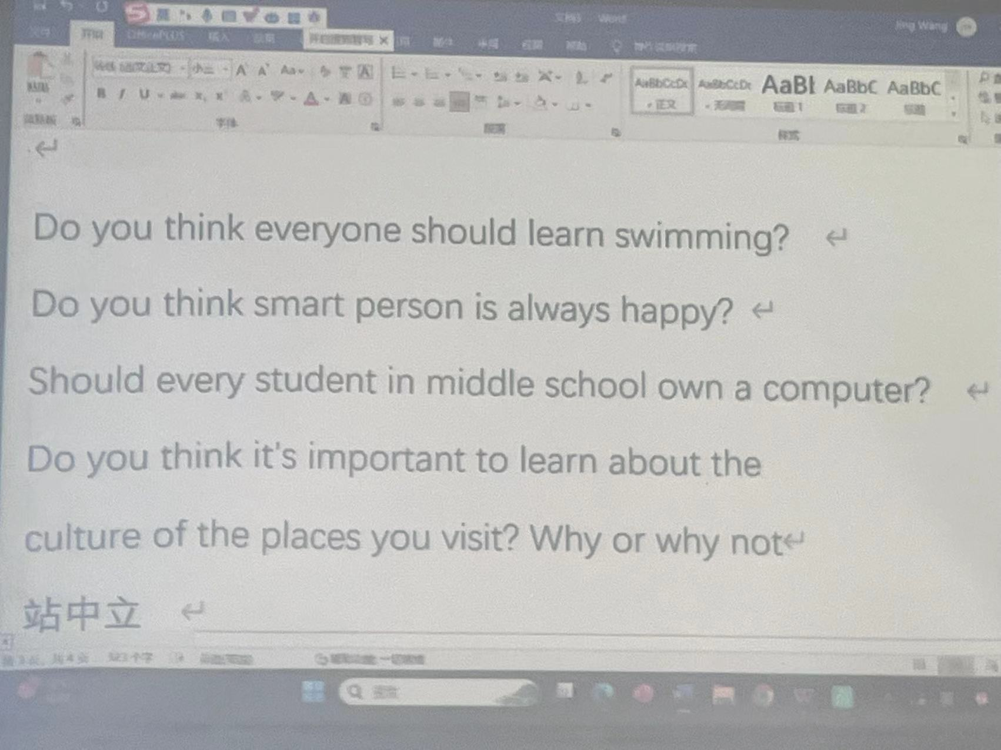学习游泳被认为是一项基本生活技能，可以使各个年龄段的人受益。学会游泳不仅可以帮助预防溺水事故，还可以提供许多健康益处，例如改善心血管健康、增强肌肉力量和耐力、减轻压力等。此外，游泳是一项低冲击运动，适合关节疼痛、运动能力受限或其他健康状况的人群。因此，许多专家建议每个人都应该学习游泳作为一项基本生活技能，就像学习阅读、写作和基本算术一样。然而，这最终取决于个人的喜好和情况，有些人可能无法接触到游泳设施或可能有使游泳不安全的医疗状况。

Swimming is considered an essential life skill that can benefit people of all ages. Learning how to swim can not only help prevent drowning accidents but also provide many health benefits, such as improving cardiovascular fitness, building muscle strength and endurance, and reducing stress. Moreover, swimming is a low-impact exercise that is suitable for people with joint pain, mobility issues, or other health conditions. Therefore, many experts recommend that everyone should learn how to swim as a basic life skill, just like learning how to read, write, and do basic arithmetic. However, it ultimately depends on personal preferences and circumstances, and some people may not have access to swimming facilities or may have medical conditions that make swimming unsafe.